Fault Scarp Detection Beneath Dense Vegetation Cover: Airborne Lidar Mapping of the Seattle Fault Zone,
Bainbridge Island, Washington State

David J. Harding
NASA's Goddard Space Flight Center, Mail Code 921, Greenbelt, MD 20771, harding@denali.gsfc.nasa.gov
Gregory S. Berghoff
Kitsap Public Utility District, Poulsbo, WA 98370, gregb@kpud.org

The emergence of a commercial airborne laser mapping industry, inspired by NASA technology research and development, is paying major dividends in an assessment of earthquake hazards in the Puget Lowland of Washington State. Geophysical observations and historical seismicity indicate the presence of active upper-crustal faults in the Puget Lowland, placing the major population centers of Seattle and Tacoma at significant risk. However, until recently the surface trace of these faults had never been identified, neither on the ground nor from remote sensing, due to cover by the dense vegetation of the Pacific Northwest temperate rainforests and extremely thick Pleistocene glacial deposits. A pilot lidar mapping project of Bainbridge Island in the Puget Sound, contracted by the Kitsap Public Utility District (KPUD) and conducted by Airborne Laser Mapping in late 1996, spectacularly revealed geomorphic features associated with fault strands within the Seattle fault zone. The features include a previously unrecognized fault scarp, an uplifted marine wave-cut platform, and tilted sedimentary strata. The United States Geologic Survey (USGS) is now conducting trenching studies across the fault scarp to establish ages, displacements, and recurrence intervals of recent earthquakes on this active fault. The success of this pilot study has inspired the formation of a consortium of federal and local organizations to extend this work to a 2350 square kilometer (580,000 acre) region of the Puget Lowland, covering nearly the entire extent (~85 km) of the Seattle fault. The consortium includes NASA, the USGS, and four local groups consisting of KPUD, Kitsap County, the City of Seattle, and the Puget Sound Regional Council (PSRC). The consortium has selected Terrapoint, a commercial lidar mapping vendor, to acquire the data. Terrapoint is a commercial spin-off from the Houston Advanced Research Center (HARC). HARC was funded by the NASA Technology Utilization Program to commercialize the Airborne Terrain Mapping technology developed by Bill Krabill of NASA’s Arctic Ice Mapping program.

INTRODUCTION

Geologic Setting

Because of the potential, but uncertain, seismic hazard in the Puget Lowland, the USGS and FEMA have recently designated the City of Seattle and the Puget Sound region as the target of focussed earthquake-hazard investigations and mitigation efforts over a five year period. The geologic setting is dominated by the Cascadia subduction zone along the Pacific Northwest continental margin where the Juan de Fuca oceanic plate subducts beneath the North American continental plate. The sources of earthquakes in the region include: (1) megathrust events between the subducting plate and the overlying plate, (2) events at-depth within the subducting plate, and (3) poorly documented, shallow, upper-crustal faults in the North American plate. The Puget Lowland is an upper-plate transpressive region, characterized by active thrust, reverse, and oblique strike-slip faults, located above the shallowly-dipping, obliquely-converging Cascadia subduction zone (Johnson et al., 1994; 1999; Pratt et al., 1997). In many respects the Puget Lowland geologic setting is analogous to the Kobe region of Japan where a 1995 earthquake on an upper-plate, strike-slip fault killed 5,500 people and caused over $150 billion in damage.

The location and geometry of shallow, upper-plate faults in the Puget Lowland is inferred from gravity and magnetic surveys, marine seismic reflection profiles, depth-to-bedrock data, and geomorphology. The faults define a northward moving ‘thin-skinned’ thrust sheet (Pratt et al., 1997). Surface exposure of fault scarps or associated tectonic landforms is extremely rare due to very dense vegetation cover, thick glacial till deposits, urbanization, and extensive waterways. Because of the lack of identified surface expressions of faults there had been, until recently, no fault trenching studies to constrain the timing of seismic events, preventing the establishment of earthquake recurrence intervals for the Puget Lowland upper-crustal faults.

One of the major upper-crustal fault systems in the region is the Seattle fault zone extending east-west across the Puget Lowland for approximately 85 km directly through the major population centers of Bellevue, Seattle, and Bremerton (Johnson et al., 1994; 1999). Paleoseismology data documents the occurrence of a large earthquake (magnitude ≥7) within the Seattle fault zone about 1,100 years. The earthquake caused abrupt uplift as large as 7 m of marine terraces, abrupt local subsidence, a tsunami in Puget Sound, and landslides, turbidity flows, and rock avalanches inferred to have been caused by ground shaking (Adams, 1992; Atwater and Moore, 1992; Jacoby et al., 1992; Karlin and Abella, 1992; Schuster, 1992). Despite intense study of the fault zone, no surface expression of faults was known. Several studies stated that there was no fault rupture of the surface (Bucknam et al., 1992; Johnson et al., 1994).

Airborne Lidar Mapping Techniques

Airborne lidar mapping can rapidly provide very high-resolution images of ground topography beneath dense vegetation cover, as well as vegetation height, by ranging to multiple features within a laser footprint. Laser pulse backscatter return energy resolved in time provides a measure of the distance to vertically separated features, including canopy layers and the ground, where illuminated with laser energy. Different approaches are used to resolve the return in time, including simple ranging to the first or last detected return, ranging to the first and last return, ranging to multiple returns, or digitizing the entire backscatter return amplitude as a function of time. Firing the laser at thousands of pulses per second and scanning the beam across the terrain using a scan mirror generates a dense distribution of ranges to the surface. Combining the laser ranging data with knowledge of the mirror scan angle, aircraft orientation from an Inertial Navigation System (INS), and aircraft position from differential kinematic Global Positioning System (GPS) techniques, yields geodetically-referenced elevation data.

A digital elevation model of ground topography beneath vegetation is generated from the laser pulse last returns inferred to be from the ground. Detection of returns from the ground depends on surface properties, altimeter properties, and data processing methods. Surface properties include vegetation height and density, the spatial and angular distribution of canopy gaps open to the ground, and the reflectivity of the ground at the laser wavelength. Altimeter properties include the off-nadir pointing angle, size and density of laser footprints, laser pulse width, detector bandwidth, signal-to-noise performance, detection threshold level, and the method used to define returns in the ranging electronics. Data processing includes the filtering methods used to identify and delete non-ground returns from the data set.

Bainbridge Island RESULTS

For hydrologic modeling and water line routing purposes, the Kitsap Public Utility District contracted with Airborne Laser Mapping (ALM) of Belfair, WA to generate a digital elevation model of the ground surface beneath the vegetation cover on Bainbridge Island (Figure 1). The island is located 12 km west of downtown Seattle in the western part of Puget Sound. The southern third of the island lies along the trend of the Seattle fault zone. Lidar mapping of the 70 square km island was done in December, 1996 during leaf-off conditions using an Optech ALTM 1020 operating in last-return mode at 3000 pulses per second (D. Ward, pers. comm.) with an emitted wavelength of 1047 nm. A differential leveling survey provided vertical control. The ALTM unit used was the first system delivered by Optech to a commercial company conducting lidar mapping. Returns identified to be from the ground by ALM using proprietary dynamic gradient threshold filters (Magnussen and Boudewyn, 1998) were used to construct a digital elevation model (DEM) gridded at a 12 foot spatial resolution.

Shaded relief renditions of the resulting ground DEM spectacularly revealed geomorphic features associated with fault strands within the Seattle fault zone. The features include a previously unrecognized fault scarp and an uplifted marine wave-cut platform (Bucknam et al., 1999), as well as tilted and differentially eroded sedimentary strata (S. Johnson, pers. comm.) (Figure 2). The fault scarp is defined by a distinct, east-west trending lineament composed of aligned, south facing topographic scarps. Relief across the scarps ranges from
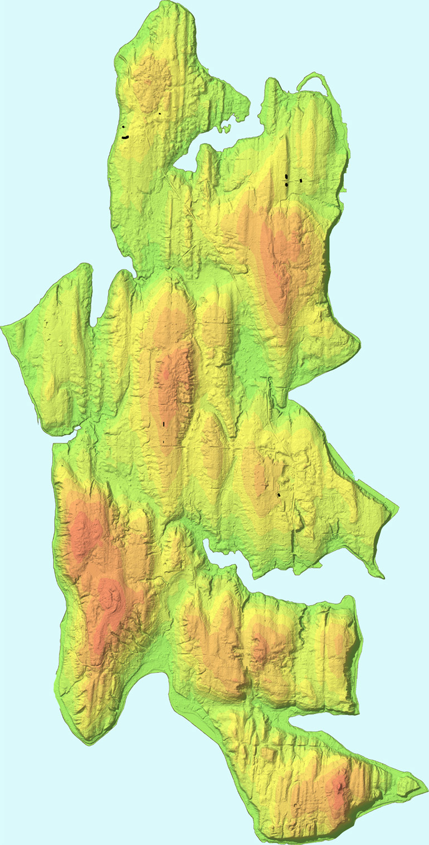
Figure 1. Color-coded, shaded relief image of the Bainbridge Island lidar-derived digital elevation model gridded at 12 foot resolution. The image is oriented with north at the top. Land elevations vary from sea level, colored green, to 130 m, colored red. Shading illumination is directed from the west, highlighting north-south oriented rock drumlins produced by Pleistocene glaciation. The island is approximately 17 km long.
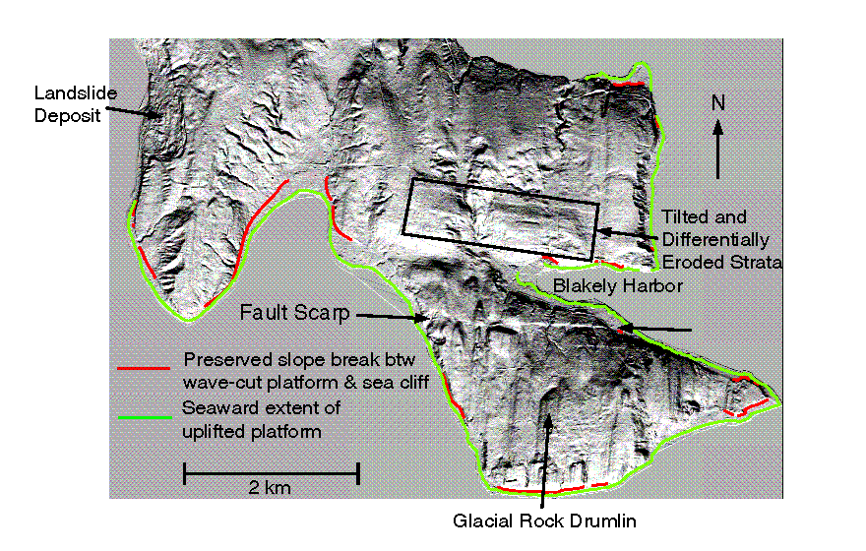
Figure 2. Shaded relief image of the southern part of Bainbridge Island where it is crossed by the east-west trending Seattle fault zone. Geomorphic features are highlighted. The image is derived from the lidar DEM gridded at 12-foot resolution, with illumination from the south.

Figure 3. Topographic profiles extracted from the lidar DEM across the south-facing fault scarp at the locations of the USGS trenches. The profiles are positioned horizontally to align the base of the scarp (indicated by vertical line). The vertical axis indicates the absolute elevation of each profile with respect to sea level. Vertical to horizontal exaggeration is 5 to 1.
about 1.5 to 10 m (Figure 3). Subsequent trenching studies across the scarps in five locations conducted by the USGS demonstrate that the topographic scarps are produced by multiple offsets on, and folding above, a south-directed, high-angle, reverse fault (Nelson et al., 1999; A. Nelson and S. Johnson, pers. comm.). Stratigraphic reconstructions of the trench exposures and radiometric dating of recovered organic material will be used to establish ages, displacements, and recurrence intervals of recent earthquakes on this active fault.

The topographic scarp, so prominent in the lidar data, was here-to-fore unrecognized due to very dense vegetation cover (Figure 4) obscuring its geomorphic expression when on the ground or in images acquired from above the canopy. The vegetation cover consists of mixed deciduous and coniferous forests that are primarily secondary regrowth developed following extensive logging around the turn of the century.

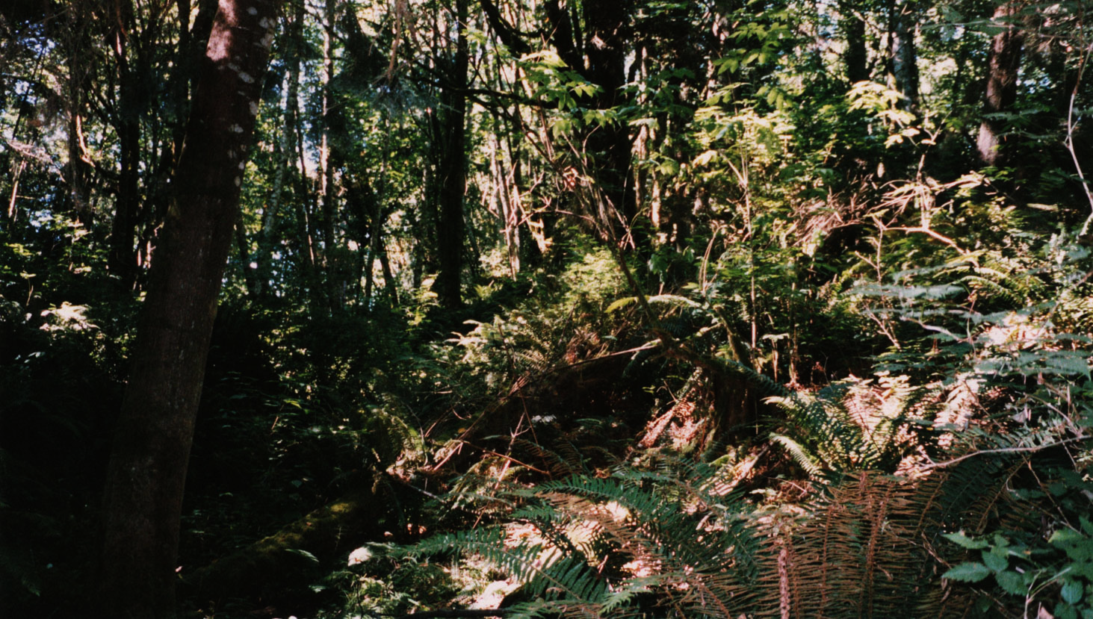

Figure 4. Field photograph at the base of the south-facing scarp viewing along the scarp to the west. Note that deciduous vegetation was fully leafed at the time of the photograph whereas the lidar data was collected during winter leaf-off conditions.

The critical parameters for resolving geomorphic features beneath vegetation cover are the density and distribution of laser returns from the ground. Figure 5 illustrates ground return shot density for the southern-most part of Bainbridge Island south of Blakely Harbor (refer to Figure 2 for the location of the fault scarp). The most prominent feature in Figure 5 is north-south zones of high data density where lidar swaths overlap. Also prominent is a linear zone of low return density around the southern part of the island corresponding to a steep relic sea-cliff above the uplifted wave-cut marine platform. Other spatial variations in data density likely correspond to variations in vegetation density and cover type (deciduous versus coniferous). The DEM for the area depicted in Figure 5 consists of 455,530 12-foot grid cells, derived using 996,840 ground returns. The distribution of number of returns per cell is shown in Figure 6. The average number of ground returns per grid cell is 2.2, corresponding to an area of 66 square feet per return.

An example of the spatial distribution of individual ground returns is illustrated in Figure 7, showing the returns at the eastern end of the fault scarp where it intersects the uplifted marine platform. Two-lane roads lacking vegetation cover (A-A’ and B-B’) are characterized by high ground return density. One of these roads (A-A’) is located on the marine platform at the slope break between the uplifted platform and relic sea-cliff. The approximately circular gaps lacking ground returns probably correspond to conifer tree crowns where the last detected returns were within the crown above the ground surface.
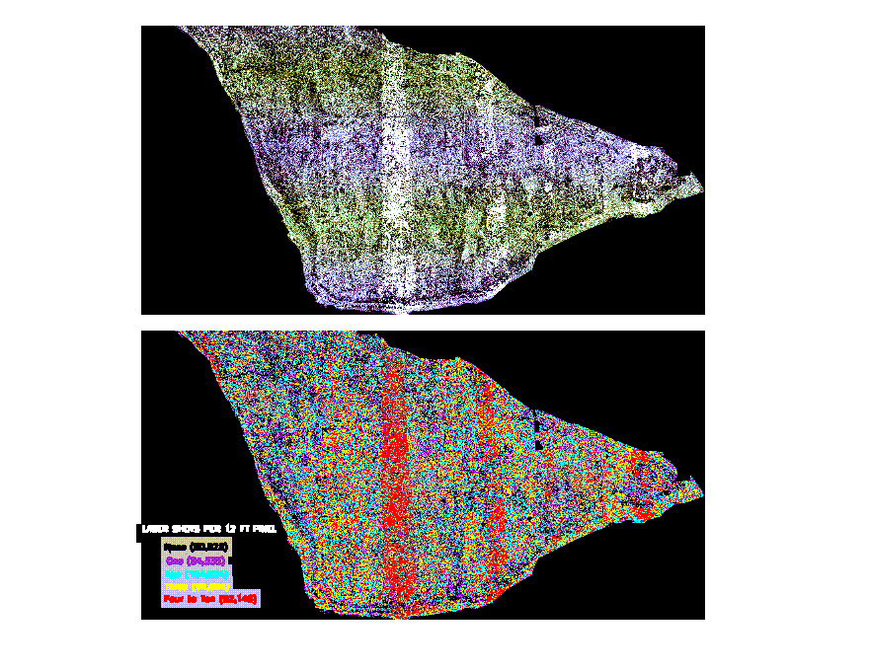
Figure 5. Ground-return shot density per DEM 12 foot grid cells for Bainbridge Island south of Blakely Harbor, as gray-scale in upper image (black = no returns per cell, white = four or more returns per cell) and color-coded in lower image (black = no returns, purple = one return, cyan = two returns, yellow = three returns, red = four or more returns per cell).
Figure 6. Histogram of number of ground returns per DEM 12-foot grid cell for Bainbridge Island south of Blakely Harbor.
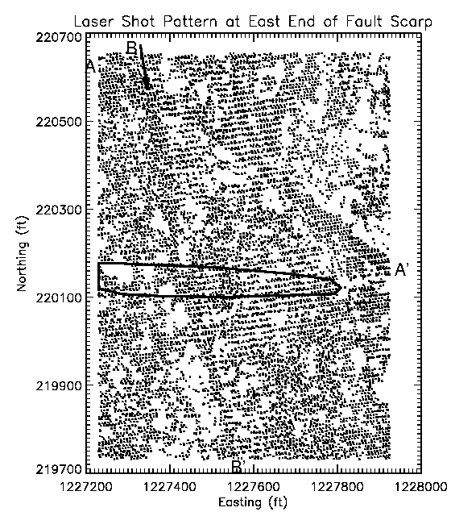
Figure 7. Map distribution of individual laser ground returns at the eastern end of the fault scarp where it intersects the uplifted marine platform. The bold line outlines the south-facing slope of the fault scarp. Linear zones of high return density correspond to two-lane asphalt roads, Country Club Road (A-A’) and Toe Jam Hill Road (B-B’). The uplifted marine platform is located to the northeast of Country Club Road.

Puget Lidar Consortium

The success of the Bainbridge Island pilot study has inspired the formation of a consortium to extend this work to a 2350 square kilometer (580,000 acre) region of the Puget Lowland covering nearly the entire extent of the Seattle fault zone (Figure 8). The consortium includes NASA, the USGS, and four local groups consisting of KPUD, Kitsap County, the City of Seattle, and the Puget Sound Regional Council (PSRC). NASA’s Solid Earth and Natural Hazards (SENH) Program is providing funding for a three-year project, led by Sam Johnson of the USGS Cascadia Earthquake Loss Products Project, to map faults in the Puget Lowland using lidar. The first year funding from the SENH program will be used to procure the lidar data for the shaded area labeled USGS/NASA in Figure 8. Funding from the other consortium members will be used this year to acquire the data for the other shaded blocks in Figure 8, including City of Seattle and PSRC funds and a substantial congressional appropriation directed to Kitsap County via the USGS. All members of the consortium will share the resulting data. Other areas with active upper-crustal faults elsewhere in the Puget Lowland will be mapped in years two and three of the SENH project, with continuing collaboration and cooperation with local agencies.

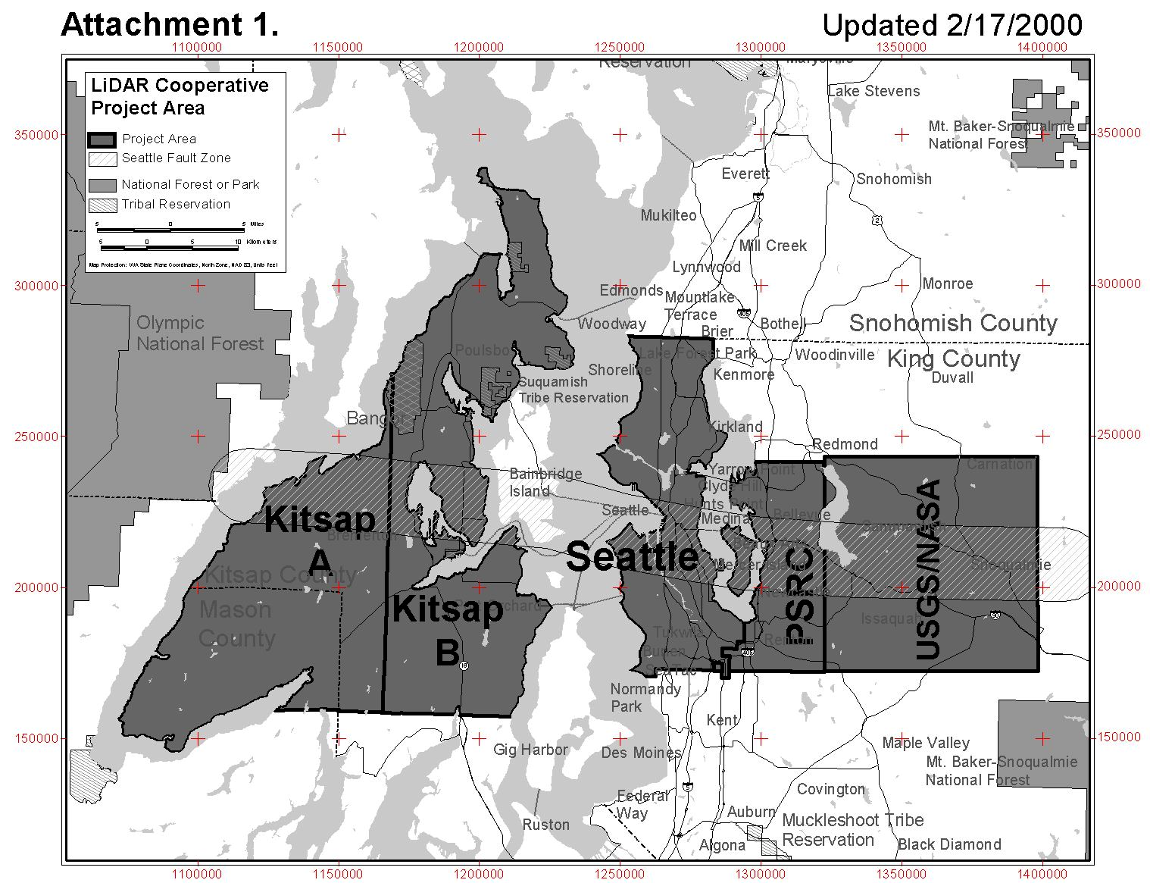
Figure 8. Areas to be mapped (dark shaded) by Terrapoint under contract to the Puget Lidar Consortium. The band of diagonal hatching indicates the location of the Seattle fault zone. Map provided by Jay Clark, PSRC.

The consortium has selected Terrapoint, a commercial lidar mapping vendor, to acquire the data. Terrapoint is a commercial spin-off from the Houston Advanced Research Center (HARC). HARC was funded by the NASA Technology Utilization Program to commercialize the Airborne Terrain Mapping technology developed by Bill Krabill of NASA’s Arctic Ice Mapping program. Terrapoint is a recent recipient of a NASA National Resources Award for Cost Effective Topographic Mapping System Commercialization in recognition of its activities. Terrapoint was selected from amongst eight proposals submitted to the consortium in response to an open, competitive bid process. Using a laser transmitter operating at 20,000 pulses per second, a polygonal scan mirror rotating 50 times a second, and overlapping data swaths Terrapoint will acquire ranging data with an average laser shot spacing of 1 m across the entire project area. Up to four returns from vertically separated surfaces will be acquired for each laser shot, significantly aiding in the identification of the ground surface beneath vegetation.

The laser range results will be combined with precise knowledge of aircraft position and laser pointing direction in order to establish the absolute coordinates and elevation of each laser return. Aircraft position will be established via a differential kinematic trajectory solution utilizing the Global Positioning System (GPS). Laser pointing will be determined by combining measurements of mirror and aircraft orientation obtained using an angle encoder and inertial navigation system (INS), respectively. Data collection is to be completed by mid-March, 2000, prior to the major onset of leaf development on deciduous trees. From this data Terrapoint will construct a DEM of the ground surface with a 1.8 m (6 ft) spatial resolution and better than 30 cm absolute vertical accuracy. The laser returns will also be used by Terrapoint to define building locations and shapes and the height of the vegetation cover. Deliverables to the consortium consist of all geolocated laser returns, ground and canopy top elevation models, and polygon shape files for buildings taller than 30 m.

This activity is an excellent example of commercialization of NASA technology and co-operation amongst federal and local agencies. In addition to playing a critical role in the assessment of earthquake hazards in the Puget Lowland, the data will also be used by the consortium members in a diverse set of applications. These will include hydrologic modeling, riparian zone and flood plain mapping, assessment of stream quality for salmon spawning, characterization of vegetation structure, urban planning, and transportation corridor mapping. The resulting data will also be used for calibration and validation of observations from NASA’s upcoming spaceborne laser altimeter missions, the Vegetation Canopy Lidar (VCL) and the Ice, Cloud, land Elevation Satellite (ICESat), and from the recently completed Shuttle Radar Topography Mission (SRTM).

Acknowledgements

The success of the Puget Lidar Consortium in carrying forward the initial results of the Bainbridge Island survey is a credit to the co-operative efforts of all its members. In addition to the authors, the representatives to the Consortium include Sam Johnson and Craig Weaver of the USGS, Jerry Harless of Kitsap County, Ken Conradi of the City of Seattle, and Jay Clark of the Puget Sound Regional Council.

References

Adams, J. (1992). Paleoseismology – A search for ancient earthquakes in Puget Sound. Science, 258:1592-1593.
Atwater, B.F. and Moore, A.L. (1992). A Tsunami about 1000 years ago in Puget Sound, Washington. Science, 258:1614-1616.
Bucknam, R.C., Hemphill-Haley, E., and Leopold, E.B. (1992). Abrupt uplift within the past 1,700 years at southern Puget Sound, Washington. Science, 258:1611-1614.
Bucknam, R.C., Sherrod, B.L., and Elfendahl, G. (1999). A fault scarp of probable Holocene age in the Seattle fault zone, Bainbridge Island,Washington [abstract]. Seismological Research Letters, 70:233.
Jacoby, G.C., Williams, P.L., and Buckley, B.M. (1992). Tree-ring correlation between prehistoric landslides and abrupt tectonic events in Seattel. Science, 258:1621-1623.
Johnson, S.Y., Dadisman, S.V., Childs, J.R., and Stanley, W.D. (1999). Active tectonics of the Seattle fault and central Puget Sound, Washington: Implications for earthquake hazards. Geological Society of America Bulletin, 111:1042-1053.
Johnson, S.Y., Potter, C.J., and Armentrout, J.M. (1994). Origin and evolution of the Seattle basin and Seattle fault. Geology, 22:71-74.
Karlin, R.E. and Abella, S.E.B. (1992). Paleoearthquakes in the Puget Sound region recorded in sediments from Lake Washington, USA. Science, 258:1617-1620.
Magnussen, S., and Boudewyn, P. (1998), Derivations of stand heights from airborne laser scanner data with canopy-based quantile estimators. Canadian Journal of Forestry Research, 28:1016-1031.
Nelson, A.R., Pezzopane, S.K., Bucknam, R.C., Koehler, R., Narwold, C., Kelsey, H.M., LaPrade, W.T., Wells, R.E., and Johnson, S.Y. (1999). Late Holocene surface faulting in the Seattle fault zone on Bainbridge Island, Washington (abstract). Seismological Research Letters, 70:233.
Pratt, T.L., Johnson, S.Y., Potter, C.J., Stephenson, W.J., and Finn, C. (1997). Seismic-reflection images beneath Puget Sound, western Washington State -- The Puget Lowland thrust system hypothesis. Journal of Geophysical Research, 102: 27,469-27,490.
Schuster, R.L., Logan, R.L., Pringle, P.T. (1992). Prehistoric rock avalanches in the Olympic Mountains, Washington. Science, 258:1620-1621.

